**Certificate**

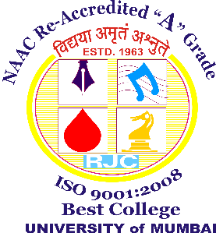

**This is to certify that Project entitled _____________________ undertaken at the _______________________________**

**by Mr./Ms. ________________________________**

**Seat no _______________ in partial fulfillment of M.Sc. IT degree (Semester IV) Examination had not been submitted for any other examination and does not form part of any other course undergone by the candidate.**

**It is further certified that he/ she has completed all required phases of the project.**

**Signature of Internal Guide Signature of coordinator**

**College Stamp & Date Examiner**

**ACKNOWLEDGEMENT**

We take this opportunity to express our profound gratitude and deep regards to our project guide Mrs. Bharati Bhole, for her exemplary guidance, monitoring and constant encouragement throughout the course of this project work. Without her encouragement and guidance this project would not have materialized.

I also extend my sincere appreciation to Principal Dr. Usha Mukundan; Course Coordinator Mrs. Bharati Bhole and Mrs. Archana Bhide; Mr. Sambhaji Hirdekar and all other staff members of Department of Information Technology, Ramniranjan Jhunjhunwala College for providing us with a wonderful opportunity to present this irreprehensible work.

A PROJECT REPORT ON

APM – ASSET PERFORMANCE MANAGEMENT

Submitted In Partial Fulfillment of the Requirements for Qualifying Degree of

Master of Science (Information Technology)

SEMESTER- IV

By

MOHITKUMAR AGRAHARI

Seat No. 42324

Under The Guidance Of

MS. BHARATI BHOLE

RAMNIRANJAN JHUNJHUNWALA COLLEGE, GHATKOPAR(W),

UNIVERSITY OF MUMBAI

July 2018